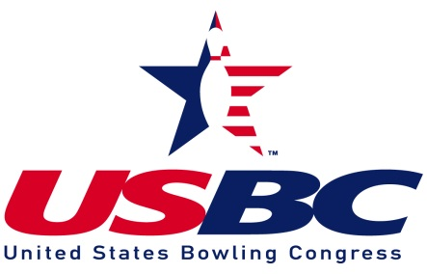
MT. PLEASANT USBC ASSOCIATION, INC.
SPRING ANNUAL MEETING
May 16, 2021

With due notice having been given in accordance with the Mt. Pleasant USBC Association, Inc. bylaws and a quorum being present, President Kevin Kirchner called the meeting to order at 6:38 pm.

It was reported 56 members present with all leagues represented.

The minutes of the previous meeting were brought to the attention of the members as being posted at the back of the room. Moved by Amanda Reynolds, second by Jim Mills to approve; motion passed.

The financial report for the year was brought to the attention of the members as being printed in the report leaflet. Moved by Ed Griffiths, second by Vicky Farrington-Howrey to approve; motion passed.
Bills to be presented: bills totalling $252.12 for year end awards and food for the banquet were presented. Kevin donated the pulled pork. It was moved by Terry Reynolds and second by Sue Strothman to pay the bills; motion passed.
Reports:
President: thanked everyone who worked thru a tough year to successfully host state tournament. With the funds raised, the board voted to pay part of everyone’s sanction fees, added to the league year-end prize fund and will contribute to the city tournaments.
Association Manager: Thanked Lil Bloom, Tom Lorenz, Clara Orman, and Kevin Kirchner for their contributions to the banquet and wonderful door prizes. A detailed report is attached.
Webmaster: Meachelle Kirchner introduced Dewey Wyatt as the new association webmaster.
Leagues: Terry Reynolds, Bob Sizemore, Pat Richenberger, Vicky Farrington-Howrey, Tammy Barr, Doug Slobodnik, and Amanda Reynolds presented year end reports from each league.
Conventions: Tammy Barr and Debi Roederer reported on the National Convention that was held virtually.
Unfinished Business – there was no unfinished business
New Business

- Election of Officers
President: Nominated were Kevin Kirchner and Danny Wohlleber. Elected was Kevin Kirchner.
First Vice President: nominated was Tammy Barr. Moved by Vicky Farrington-Howrey, seconded by Eddie Griffiths that Tammy be elected by acclimation; motion carried.
Directors: there are 3 directorships open. Nominated were Melinda Chatfield, Eddie Griffiths, Lorrie Parker and Dawn Bechtal. Elected were Melinda, Eddie, and Dawn.
Adult Male to Youth Board: nominated was Doug Slobodnik. Moved by Amanda Reynolds and second by Vicky Farrington-Howrey to be elected by acclimation; motion carried.
- Upcoming Meetings
The Fall Association Meeting will be held September 19 at 4:00 pm at the Alleys; the next board meeting will be August 22.
Following Adjournment of the Business Meeting at 7:15 pm, a Memorial Observance and awards ceremony was held with social hour to follow.
Awards
Awards were presented by Tammy Barr and Danny Wohlebber the City Mixed Doubles Tournament; Alexis Wohlleber and Eddie Griffiths, champions.
Hall of Fame Honors: Kenny Koch and Amanda Reynolds. Announced the “All Star Team” members for adults: Mitch Banes, Tammy Barr, Cheryl Bloom, Melinda Chatfield, Marcus Garcia, Kevin Kirchner, Chris Kracht, Scott Strothman Kevin Wellington, and Alexis Wohlleber. For youth: Kellton Burke, Braden Frueh, Conner Sizemore, Shyann Smith, Chayse Stauffer, Wyatt Baker, Bethany Drury, Alec Payne, McKayla Taylor and Cadenn Vaughn. Bowler of the Year: Cheryl Bloom.
Recipients of the Bob Russell Memorial Sportsmanship Award were Conner Sizemore and Kylee Taylor.

